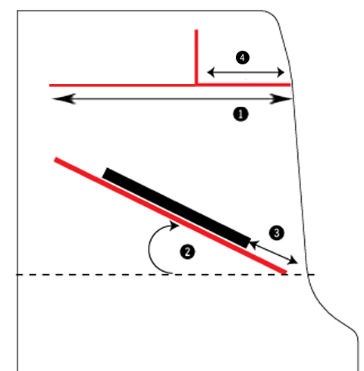
1 = 22’’
2 = 40°
3 = 3-¾’’
4 = 5-¾’’
Bezel = 22-7/16’’ x 20-¼’’

Marquee = 22-3/8’’ x 5-7/8’’

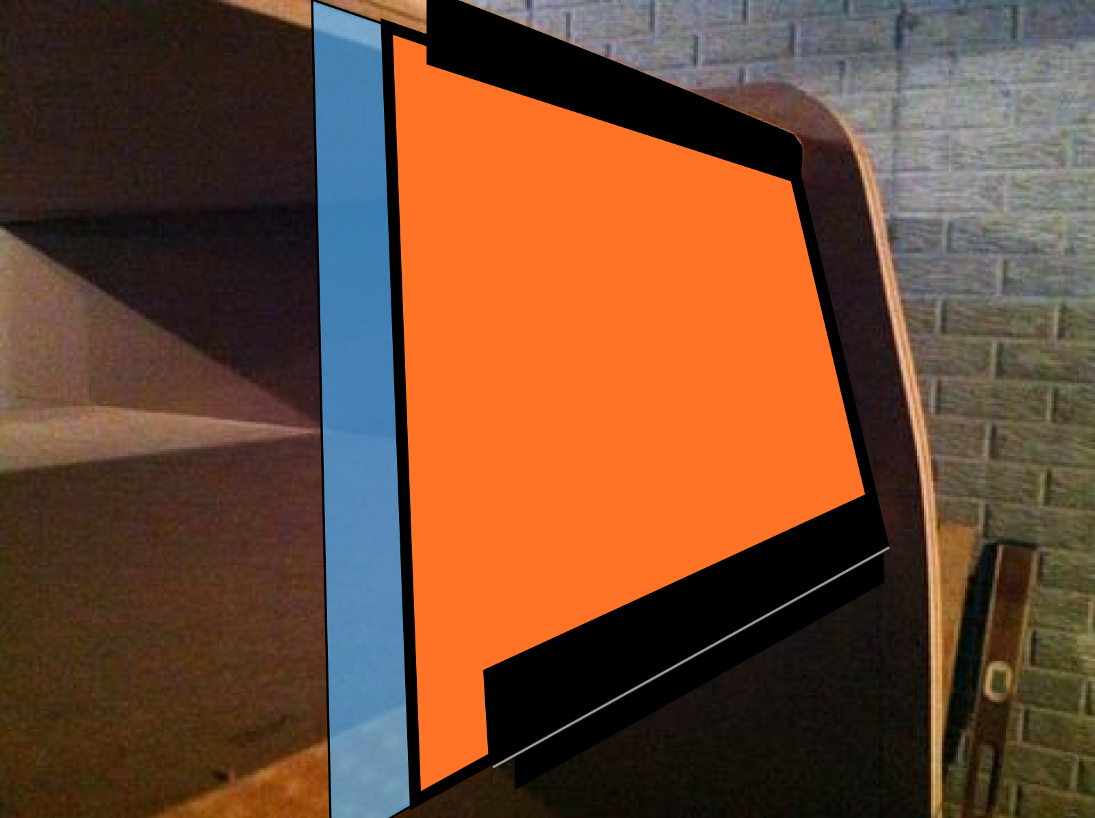

Panel :
Panel = 22-3/8’’ x 8-7/16’’
All measurements are from the left and top (unless noted)
Joystick: 7 1/4" x 4 3/8"
Player 1: 11 3/16" x 2 3/8"
Player 2: 12 11/16" x 2 3/8"
Jump: : 16 11/15" 2 3/8"
Hole 1(top left): .75" x 1 1/8
Hole 2: 7 11/16" x 1 1/8"
Hole 3: 14 11/16" x 1 1/8"
Hole 4: 21 5/8" x 1 1/8"
Hole 5(bottom left): .75" x 7 1/4"
Hole 6: 7 11/16" x 7 1/4"
Hole 7: 14 11/16" x 7 1/4"
Hole 8: 21 5/8" x 1 7 1/4"
Slot is 3/16" wide 5 5/8" long and at 3/4" from the bottom
There is a notch cut at the top on the reverse side this is 1" wide 1/8" deep for the full length of the board.
The joystick is square and countersunk. The countersunk square is 4" x 2 3/4"
Can someone verify the CP size for me? My original DK CP is 8 1/4" deep and not 8 7/16"

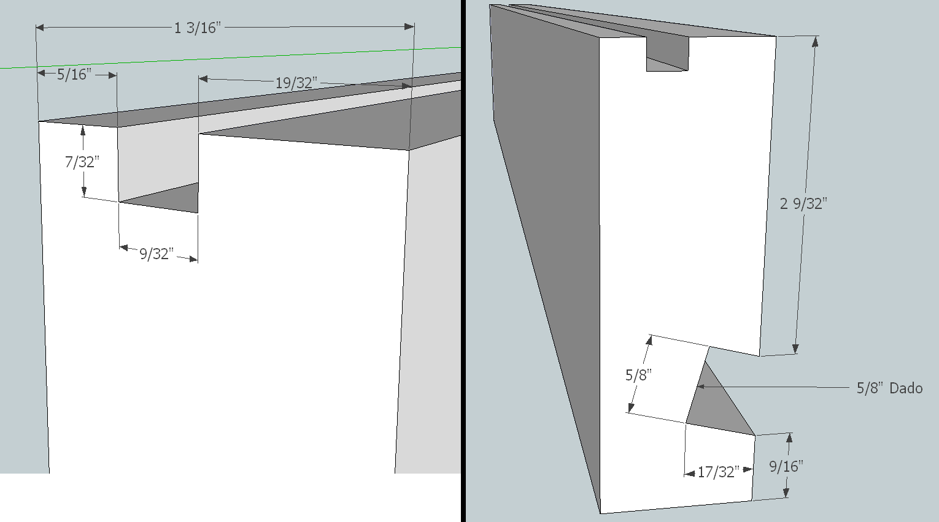
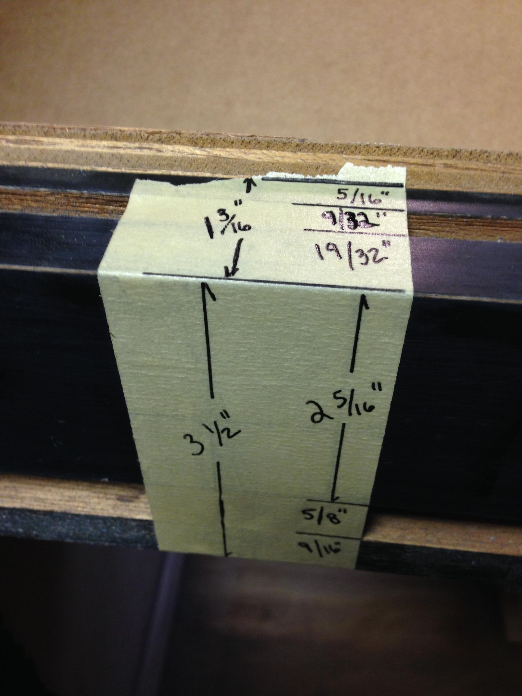
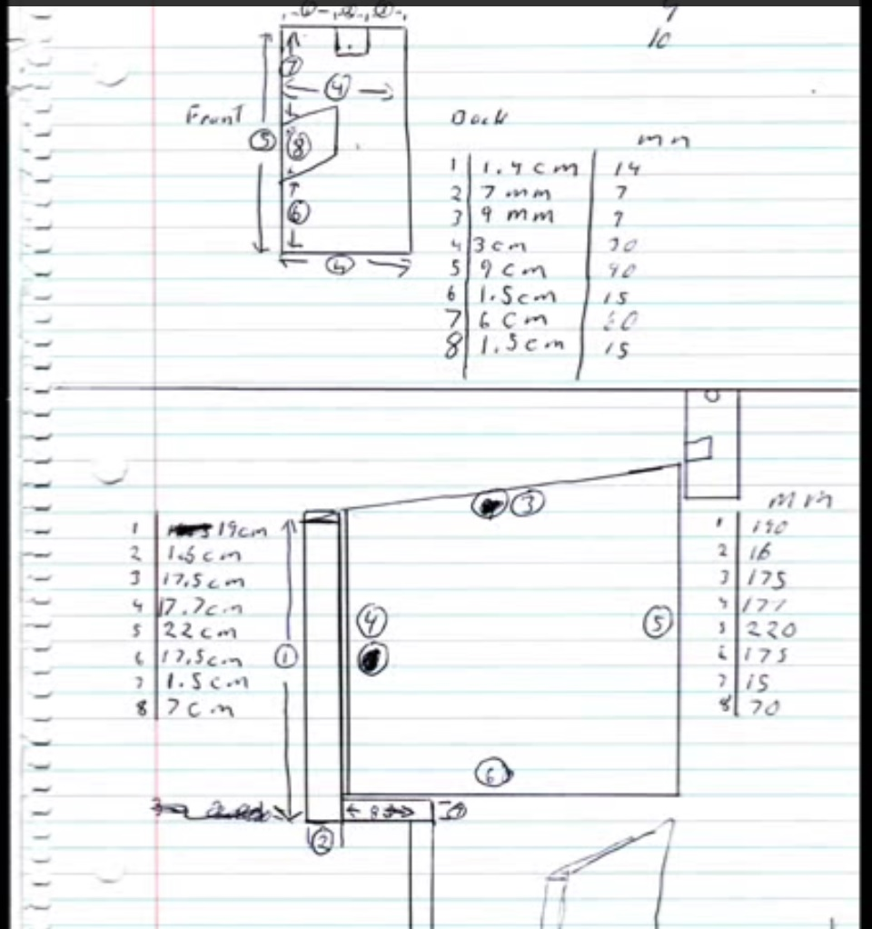
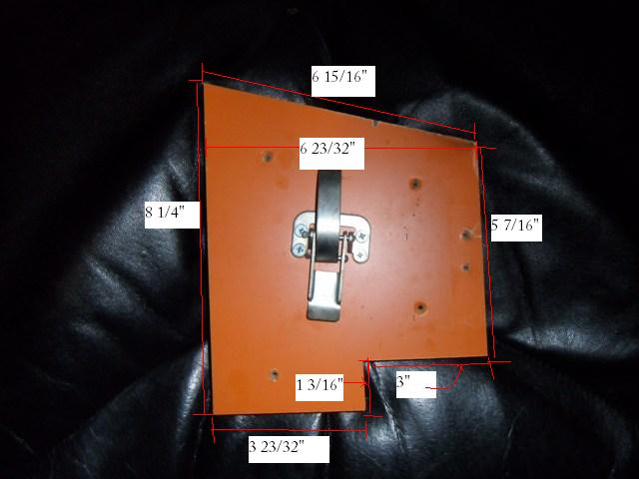

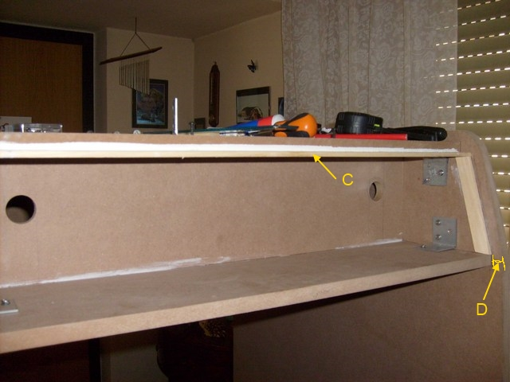
C = 5 mm
D = 12 mm
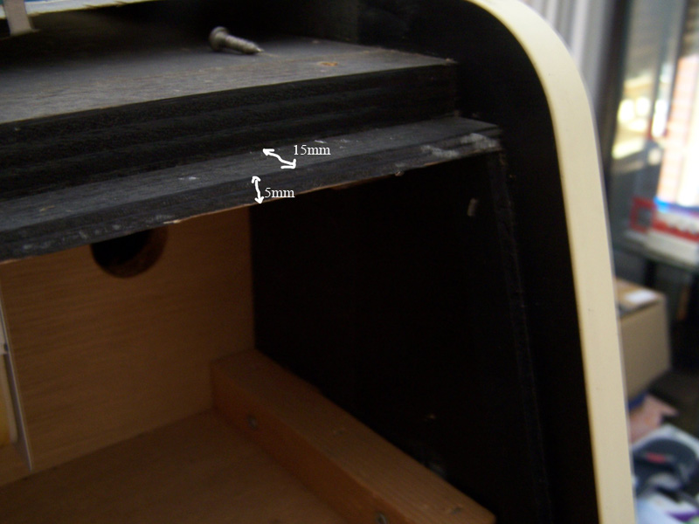

The simple answer is you have a 0.75" offset from the front for everything you're looking for in that marquee area. This 0.75" does not count t-molding thickness. In other words:
- The cabinet-top is positioned 0.75" down from the top edge of the cabinet-side. The cabinet-top also has a rabbet cut into the upper corner to allow the curved marquee retainer to fit around it
- The front edge of the cabinet-top is 0.75" back from the front edge of the cabinet-side
- The front edge of the marquee-bottom is 0.75" back from the front edge of the cabinet-side
Also, there is 5.25" between the bottom of the cabinet-top and the top of the marquee-bottom. You also want to keep in mind that right around the marquee the sides have that little bump that juts out a bit. This means the marquee technically sits angling back a bit - that is, the front edge of the cabinet-top is a bit behind the front edge of the marquee-bottom.
One thing to thing about, too, is the brackets that will hold the marquee - the original metal ones are probably a bit $$ to buy to use. So you might end up having to use "normal" marquee retainer parts that are plastic and cut to length. I'd suggest ordering these now so you can plan for any minor adjustments to the 0.75" to get stuff to look right.
I'll see if I can get some pics uploaded showing some of the detail around the marquee later today.
